**Unable to View Or Make Schedules**

Stores may call or make tickets regarding their inability to view/create schedules for certain weeks. These are 3 of the most common issues and their solutions.

1. “This Subgroup Does Not Contain Any Shifts”: When this error occurs, it is due to a store creating a schedule before their Labor Demand generates. Labor Demand is just the “hours” given to the store for various tasks and are delegated to the employees for their work week. It is generated 2 weeks ahead of time, on Sundays.

* First on the employee’s workday check if the schedule is published or a draft.

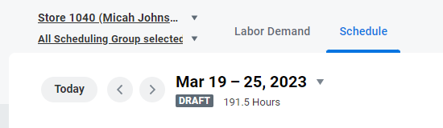

Or

* If the schedule is in draft, simply press the Actions button on the top right of the page and hit “Clear Schedule”. The error will be wiped, and the store will be prompted to create a new schedule. Which should generate normally.

* If the Schedule is Published. Escalate to Level 2. The schedule will need to be manually rescinded by another team.

1. 401 Error: This error appears when a manager makes changes to certain shifts after publishing the schedule and attempts to publish the entire schedule a 2nd time.

* In these situations, first find any shifts that appear in draft status on the employee’s Scheduling Hub page and click them to open the edit menu.

* Once in the edit menu, click the “Publish” button there to manually create the change.

* Advise the manager to do this with all draft shifts and all changes will be successfully published. Advise the store they can only publish these edits individually after publishing the entire schedule.

1. 500 Error: This issue occurs when a manager has not been made a scheduling partner of a location they are managing, the error appears when they attempt to access scheduling functions.

* Using the search bar on your own personal workday account, search “Org: XXXX” with the respective store number, their Supervisory Organization should show in the dropdown menu.
* Once on their supervisory org. page, click the 3 dots next the store name at the top of the page to open the options menu and select “Assign Roles”.

* On the Assign Roles page, we will manually add the name of the manager needing access by typing their name in the “Assigned To” field searchbox. Once done hit the orange “OK” button at the bottom of the page to submit the change.

* After adding, have them check if they are able to see the schedule. If they still have issues, escalate to Level 2.